# Statistical models 🡪

head(cars)



m <- lm(dist ~ speed, data=cars)

m

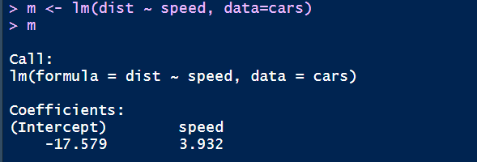

summary(m)

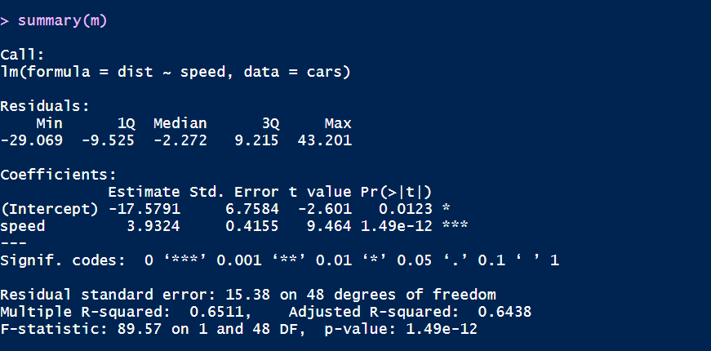

anova(m)

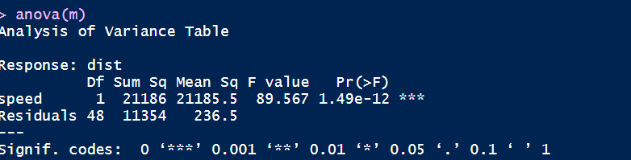

residuals(m)[1:10]



p <- predict(m, data.frame(speed=1:30))

p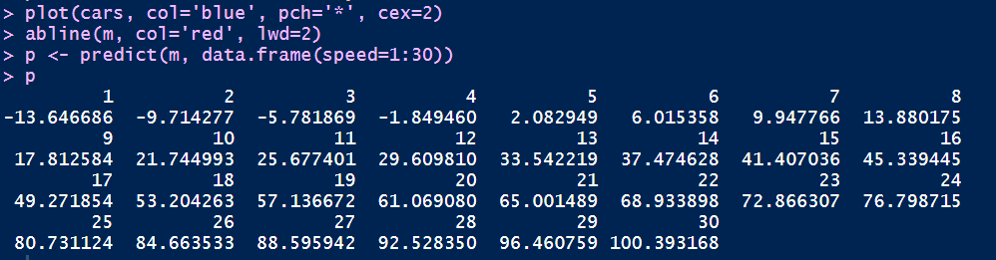

plot(cars, col='blue', pch='*', cex=2)

abline(m, col='red', lwd=2)

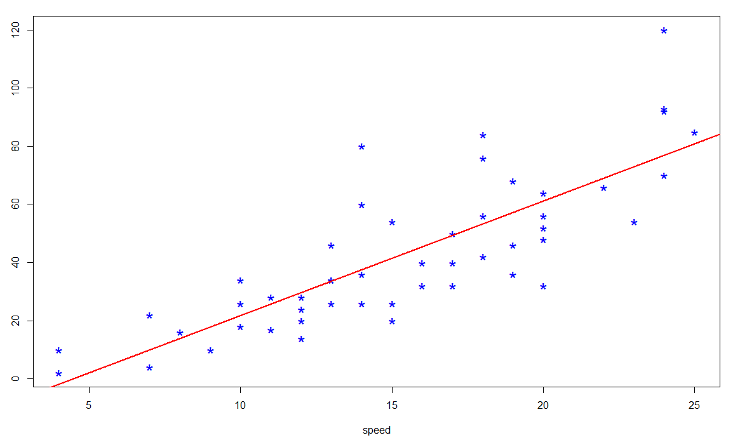

plot(1:30, p, xlab='speed', ylab='distance', type='l', lwd=2)

points(cars)

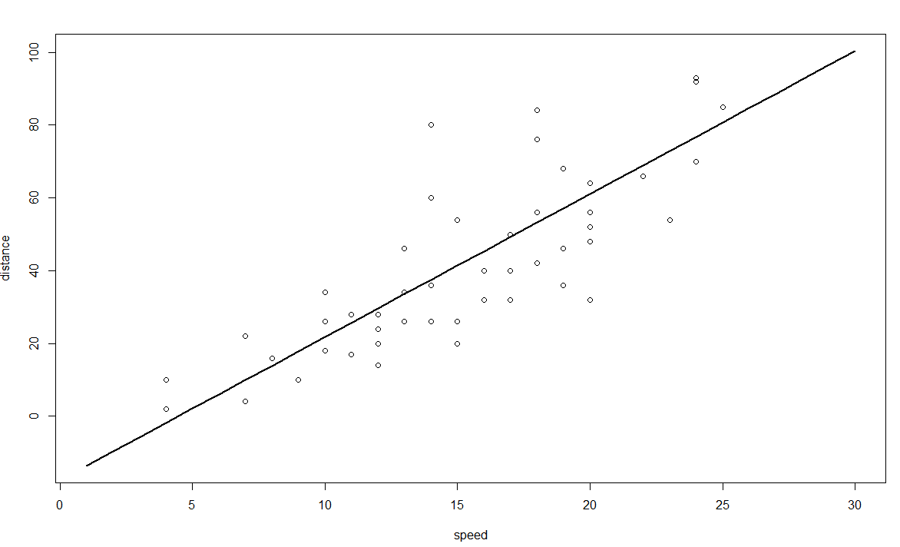

cars$above40 <- cars$dist > 40

mlog <- glm(above40 ~ speed, data=cars, family='binomial')

mlog

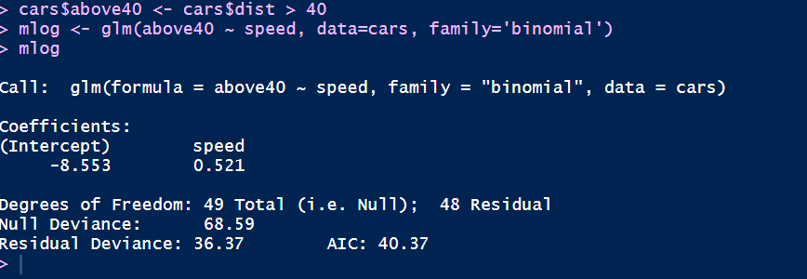

p <- predict(mlog, data.frame(speed=1:30), type='response')

plot(cars$speed, cars$above40)

lines(1:30, p)

